Module 2
Identity & Authentication Lab
Lab 2.1 — OpenLDAP — Build Your Own Active Directory
1. ldapsearch returning both users
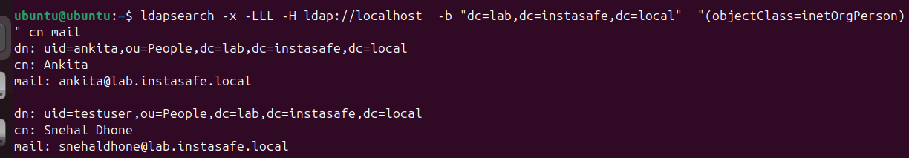
2. ldapwhoami success AND failure (error 49)

Lab 2.2 — Keycloak SSO — Build Your Own Identity Provider
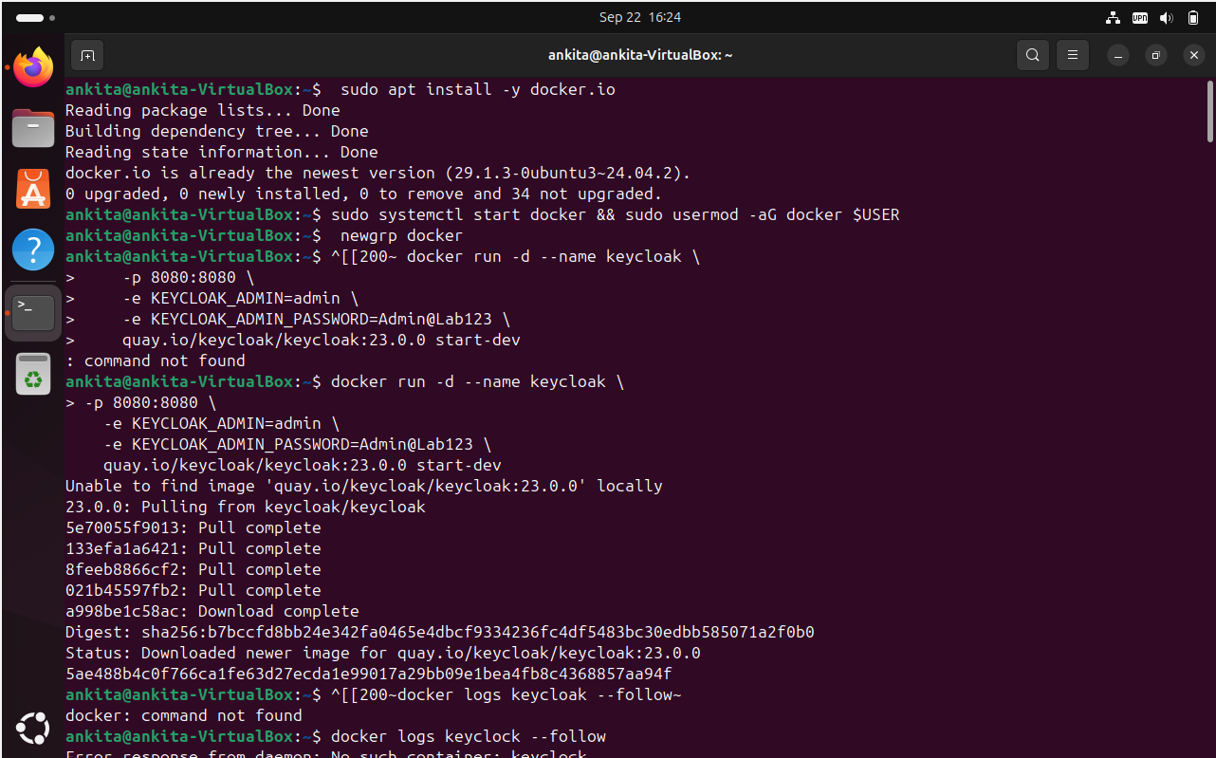
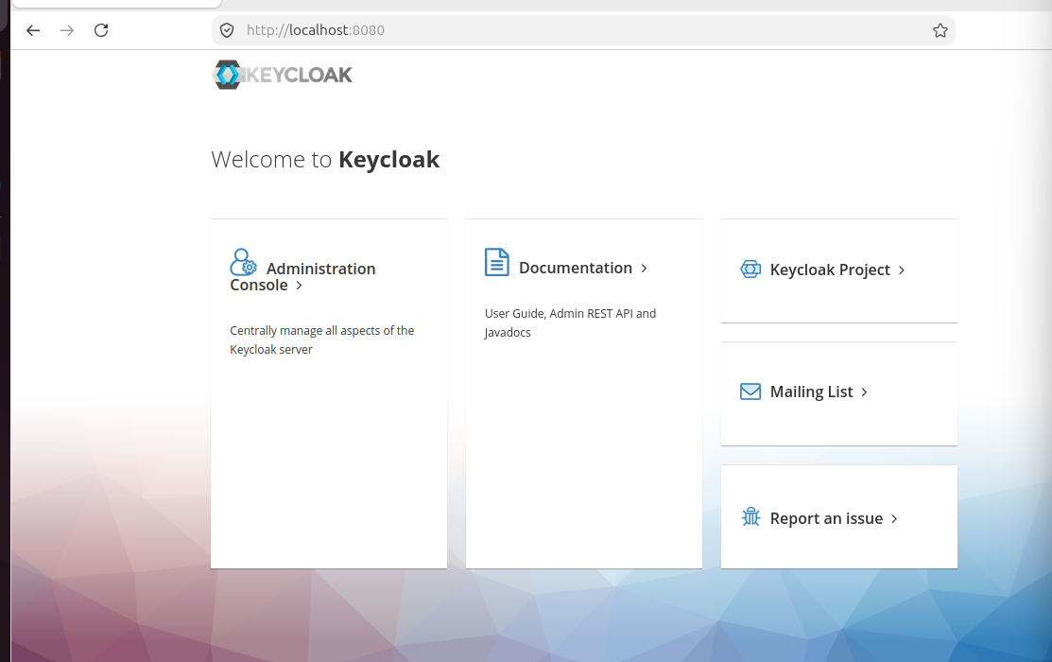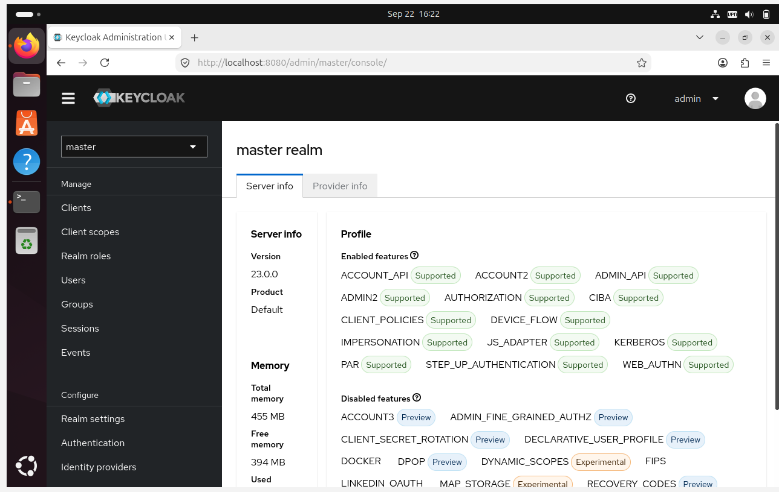

- Create a Realm as a instasafe-lab
- Then ADD user
- Set a password
- Then I created a group
- Add testuser to the group
- Verify using the API
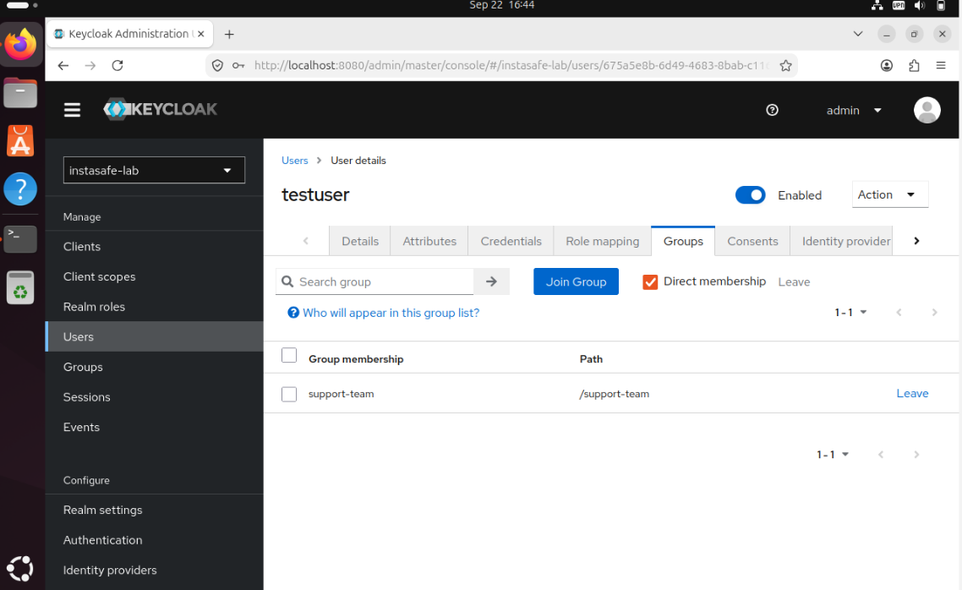

I got API Token
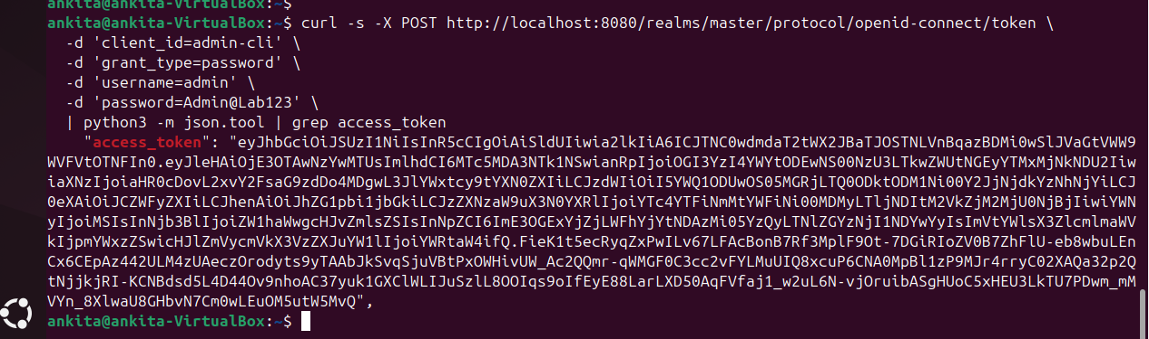

ADD MAPPER FOR USER AND GROUP
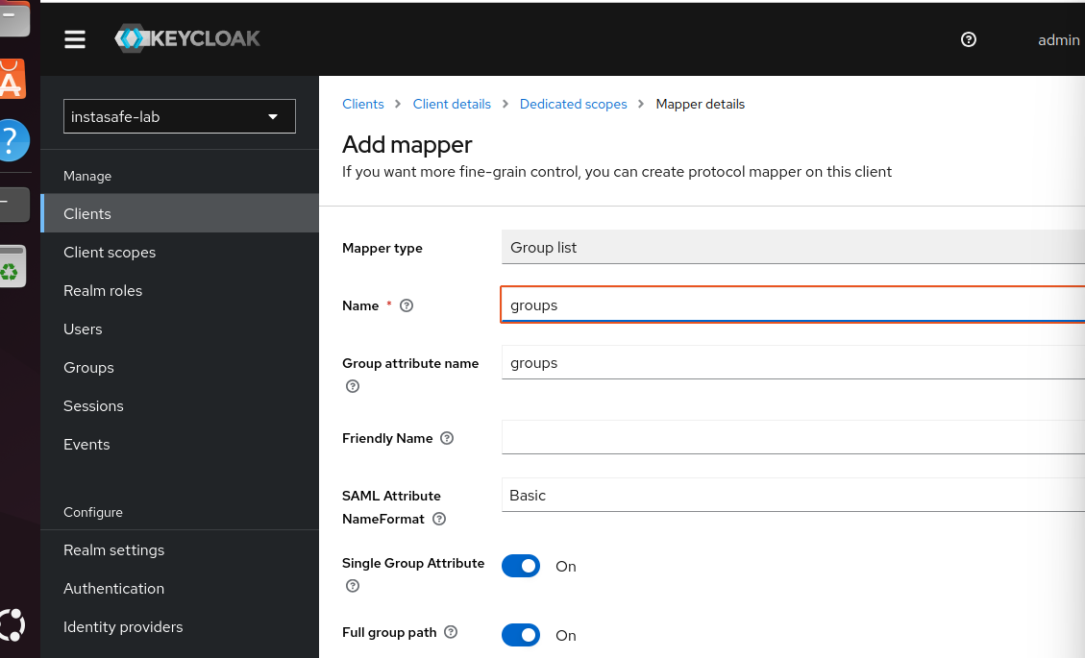
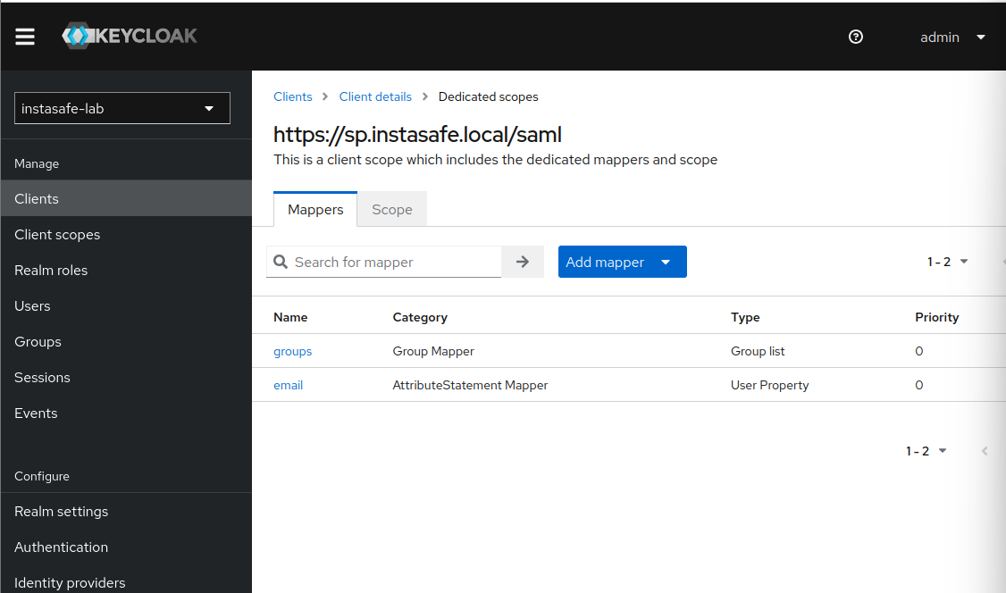

KEYCLOCK IdP metadata
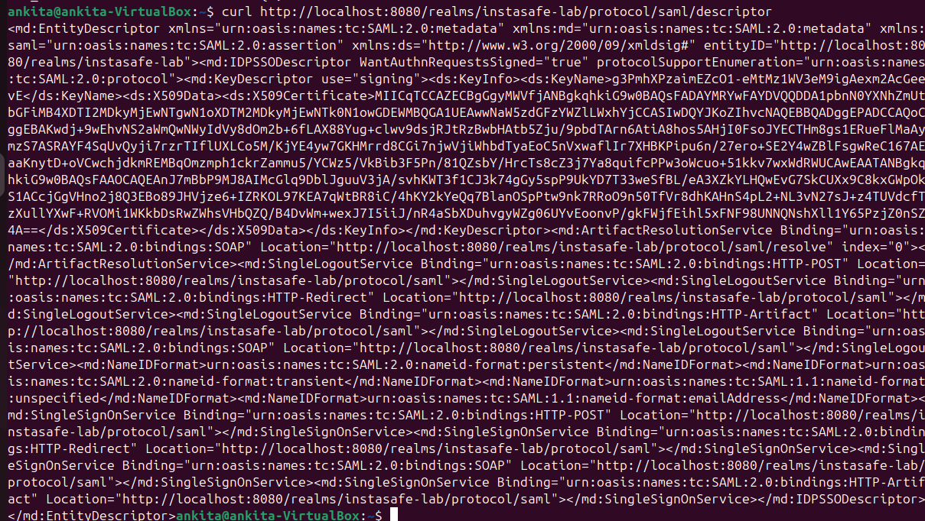

File is creates
